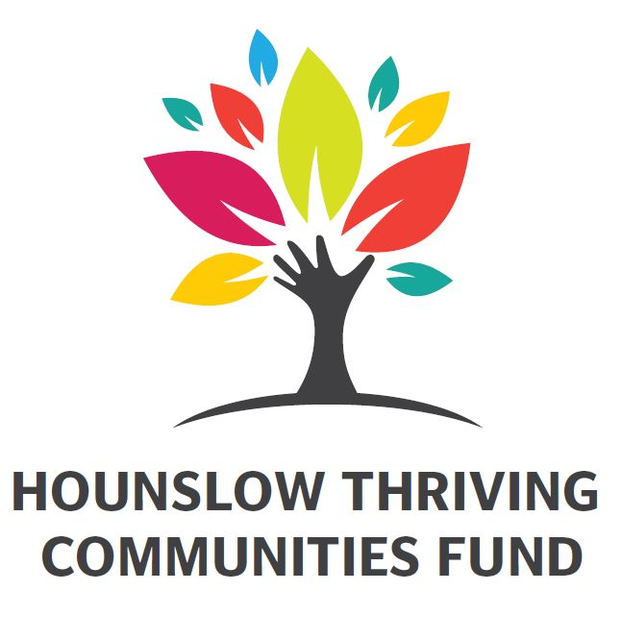

Please complete this form in full to tell us about your project.

|  |  |
| --- | --- |
| Deadline for Applications | Decision Communicated |
| Friday 28th February 2025 9am | Within 4 weeks of receiving applications |

We encourage you to contact the Thriving Communities Grant Managers to discuss your idea and application

Once your application is complete, please submit to [community.development@hounslow.gov.uk](mailto:community.development@hounslow.gov.uk)

Please also refer to the Fund Guidance document available at

[**https://www.hounslow.gov.uk/downloads/20047/community_and_voluntary_sector_services**](https://www.hounslow.gov.uk/downloads/20047/community_and_voluntary_sector_services)

# **Section 1: About you**

|  |  |
| --- | --- |
| 1. **Your name – Must be a Councillor** |  |
| 1. **Contact email** |  |
| 1. **Contact telephone number** |  |

# **Section 2: Your proposal**

|  |  |  |  |  |
| --- | --- | --- | --- | --- |
| **1. Project name** |  | | |  |
| **2.Project purpose**  (20 word limit) |  | | |
| **3.Project address** |  | | |
| **Postcode:** | |  |
| **4. Which ward will your project be delivered in?** | Choose an item. | | |
| **5.Start date** |  | | | *Tell us when this funding will first be used this should be within 3 months of the funding being awarded* |
| **6.End date** |  | | | *Tell us when the funding will last until –. this should be within 12 months of the project start.* |
| **7. Priority areas** |  | Physical improvements to an area eg. improvements to war memorials and/or sights of historical interest or installation of planters or benches | | *Please tell us which priority area(s) your proposal addresses.* |
|  | Improvements to community infrastructure eg. including physical resources for community centres/ youth clubs such as purchase of chairs, tables or sports equipment | |
|  | Activities which involve people in improving their environment eg. community litter picks or community planting events | |
|  | Community art installations/exhibitions eg. arts projects which involve people coming together to produce an artwork for display in their local community | |
|  | Other: | |

|  |  |  |  |  |  |  |  |  |
| --- | --- | --- | --- | --- | --- | --- | --- | --- |
| Section 3: Your application  Please answer the questions below telling us more about your project.   |  | | --- | | 1. **Please tell us about your idea. What are you applying for funding for? What will be delivered or purchases with the funding i.e. number of activity sessions, material or equipment for a community space etc** | |  | | 1. **Why is your project needed? Tell us how the community is involved and if they are supportive?** | |  | | 1. **Who will benefit and how many people will benefit? For example 20 young people, 18 older people, tenants on a housing estate. NB. You must include an estimated number.** | |  | | 1. **What difference will this project make? For example, community feels safer, community feel a sense of pride in the community** | |  | |

# **Section 4: Project Costs**

|  |  |  |  |
| --- | --- | --- | --- |
| 5. Tell us how much your project costs and how much you are applying for. | | | |
| Item / Activity | **Total Cost** | **Total Requested from LBH** | **Source of additional funding** |
|  | £ | £ |  |
|  | £ | £ |  |
|  | £ | £ |  |
|  | £ | £ |  |
|  | £ | £ |  |
|  | £ | £ |  |

|  |  |
| --- | --- |
| Total Project Cost | £ |
| Total Requested from LBH | £ |

# **Section 5: Project Delivery**

Please tell us who will be delivering the project - group of residents (formal or informal) or a community group/organisation or a council service

|  |  |
| --- | --- |
| **Group of residents – formal or informal – main contact** |  |
| **Community group or Organisation - main contact and name of organisation** |  |
| **Council service - main contact and team** |  |
| **Address** |  |
| **Phone number** |  |
| **Email address** |  |

***N:B – we can contact the group/organisation for relevant documents***

**Now please return your proposal to:**

[community.development@hounslow.gov.uk](mailto:community.development@hounslow.gov.uk)